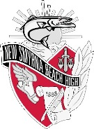
New Smyrna Beach High School
Karen M. Chenoweth, Principal
1015 Tenth Street, New Smyrna Beach, FL 32168
386-424-2555 Fax 386-409-5625

Teachers, Parents and Students!

We are excited to announce that your student has the opportunity to utilize the online USA Test Prep platform in order to prepare for upcoming graduation required assessments and End of Course assessments. Below, please find the account set up instructions for your student to access this beneficial test prep platform. Please know that this program can be accessed at school, at home, or from any device that can access the internet!

Setting up a Student Account
- Go to www.usatestprep.com
- Click orange LOGIN button, then click Create an account on the left
- Account ID: cudas55
- Student code: stu4561
- Click on check activation code
- Create student username & password (Please use naming conventions below)
Student Username: 1+ALPHA+1 (ex: 1UXOY1)
Student Password: 8-digit Birthdate (ex:10172007)

During the 2017-2018 school year, your student can access test prep materials for the subjects listed below:
- FSA ELA Grade 10
- FSA Algebra 1
- FSA Geometry
If your student has any questions regarding USA Test Prep, he/she can visit the Cuda Zone in 1-114 during Office Hours. Ms. Casey, the Literacy Coach, and Ms. Jackson, the Math Coach, would be glad to assist you.

Thank you in advance for helping to encourage your student to utilize the USA Test Prep materials! Please contact Eleeta Sue Hopkins 386-424-2555 (ext. 38585) with any questions or concerns.

Thank you,

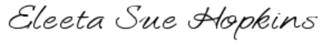
Eleeta Sue Hopkins
Testing Coordinator
(386) 424-2555, ext. 38585
eshopkin@volusia.k12.fl.us

