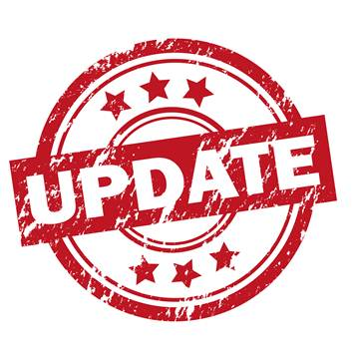
April and May 2019 Testing Dates

4/2: FSA Writing for 9th grade (adjusted bell schedule) AM and PM sessions
4/3: FSA Writing for 9th make-up
4/4: FSA Writing for 10th grade (adjusted bell schedule) AM and PM sessions
4/-4/12: FSA Writing make ups 9th and 10th
4/15-4/17: Pert testing (all) 3 days ONLY
5/1: FSA reading 9th session 1 (adjusted bell schedule) AM and PM sessions
5/2: FSA reading 9th session 2 (adjusted bell schedule) AM and PM sessions
5/3: FSA reading 9th make-up session 1 and 2
5/6: FSA reading for 10th session 1 (adjusted bell schedule) AM and PM sessions
5/7: FSA reading for 10th session 2 (adjusted bell schedule) AM and PM sessions
5/8: FSA ELA and Writing make ups 9 and 10
5/9: Alg. 1 EOC session 1 (adjusted bell schedule) AM and PM sessions
5/10: Alg. 1 EOC session 2 (adjusted bell schedule) AM and PM sessions
5/13: Geometry EOC session 1 (adjusted bell schedule) AM and PM sessions
5/14: Geometry EOC session 2 (adjusted bell schedule) AM and PM sessions
5/15: US History EOC
5/16: Bio EOC (Group 1)
5/17: Bio EOC (Group 2)
5/20-5/29: FSA ELA, Alg. 1 EOC, Geometry EOC, US Hist EOC and Biology EOC make ups

Important Dates:
Seniors’ last day: May 20
Memorial Day: May 27th
Graduation rehearsal: May 29th
Last day of testing: May 29th
Last day of school: May 31

