PRACTICE PERT TEST – ALGEBRA PORTION

- Multiply: 2(x + 3)
- 2x + 3 B
- 2x + 6
- x + 6
- 2x + 5

- Simplify by clearing parentheses and combining like terms: 8k – 4(k – 1) + 7 – k

- 3k + 11 A
- k – 11
- k – 3
- 3k – 11

- Solve the equation: q – 14 = 6

- q = 8 C
- q= -8
- q = 20
- q= -20

- Which of the following is the solution to the equation c + (4 – 3c) – 2 = 0

- -1 B
- 1
- 0
- 2

- What is the solution y – 2 > 1

- (3, infinity) A
- (-infinity, infinity)
- (3, -3)
- [3, infinity)

- Which of the following is a solution to x² - 6x + 5 = 0?

- x = -1 B
- x = 5
- x = -5
- x = $\frac{1}{5}$

- Factor: x² + x – 12
D
- (x – 6)(x + 2)
- (x + 6)(x – 2)
- (x + 3)(x – 4)
- (x + 4)(x – 3)
- (x – 4)(x – 3)

- Simplify the following expression: $\frac{3x⁴y²}{xy²}$

- 3x²y C
- 3x⁴y²
- 3x³
- 3x⁴y

- What is the value of the algebraic expression 6x(y²)z, if x = $\frac{1}{2}$, y = -1, and z = 2

- 1 C
- 12
- 6
- -6

- Which of the following is equivalent to the expression (3ab)(-5ab)?

- -2ab C
- -15ab
- -15a²b²
- -2a²b²
- If $\frac{4a}{2}=12$, then a =?

- 2 C
- 1
- 6
- 8

- -2(3x – 4y)

- 2xy B
- -6x + 8y
- -6x – 8y
- 24xy
- -6x – 4y

- If x = 5, then -4x² + 6x – 3 =

- 427 C
- -88
- -73
- -67
- -13

- Simplify: $\frac{n+3}{n^{2}+3n}$

- $\frac{3}{n+5}$ E

- $\frac{1}{n+5}$

- $\frac{1}{n²}$

- $\frac{1}{2n}$

- $\frac{1}{n}$
- Simplify: (-5x⁶y)(7x⁴y⁵)

- -35$x^{10}$y⁶ A
- 35$x^{24}$y⁵
- 2$x^{10}$y⁶
- 35$x^{10}$y⁶
- -35$x^{24}$y⁵

- (x – 3)² =

- x² - 3x + 9 C
- x² + 3x + 9
- x² - 6x + 9
- x² - 6x – 9

- Solve for n: 6 + 5n = t

- t – 11 E
- t - $\frac{6}{5}$
- t + 1
- $\frac{t+6}{5}$
- $\frac{t-6}{5}$

- Evaluate the expression $\frac{3a+2b}{2}$ when a = -3 and b = -4

- $-\frac{1}{2}$ B

- $-\frac{17}{2}$

- $\frac{1}{2}$

- $\frac{17}{2}$

- Evaluate: $\frac{3x-y}{6z-x}$, if x = 1, y = -4, and z = 6

- $\frac{1}{7}$ C
- $-\frac{1}{7}$
- $\frac{1}{5}$
- $-\frac{1}{5}$

- Simplify: 8y – 2 -3(y – 4)

- 5y + 10 A
- 11y – 6
- 5y – 6
- 5y – 14

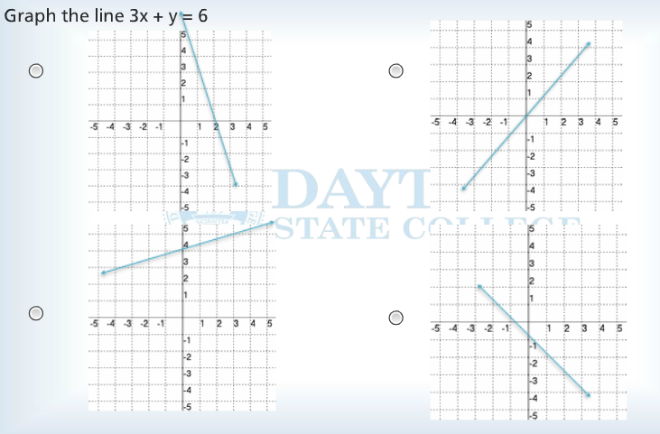

- Write the fraction in lowest terms: $\frac{36a³bc²}{24ab⁴c²}$

- $\frac{3b³}{2a³}$ C

- $\frac{2b³}{2a²}$

- $\frac{3a²}{2b³}$

- $\frac{2a²}{3b³}$

- Subtract the polynomials: (9x² - 4x + 11) – (3x² - 2x + 2)

- 6x² -2x + 13 C
- 6x² -6x + 13
- 6x² -2x + 9
- 6x² -6x + 9

- (x + 2)(x² - 2x + 4) =

- x³ - 4x² + 8x + 8 B
- x³ + 8
- x³ + 8x + 8
- x³ + 4x² - 8x + 8

- Multiply: 2x(3x² - 5x – 3)

- 6x³ - 10x² - 3x C
- 6x³ - 5x² - 6x
- 6x³ - 10x² - 6x
- 6x³ - 5x - 3

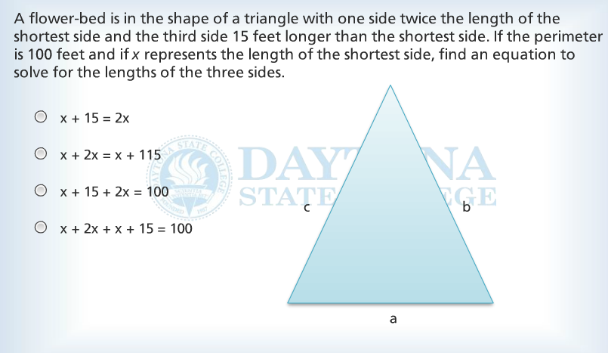

x + 2x + x + 15 = 100

- Divide: $\frac{14m^{2}-28m^{8}+7m}{7m}$

- 2m² - 4m⁸ + m C
- 2m - 28m⁸ + 7m
- 2m - 4m⁷ + 1
- 2m – 4m⁷

- Which of the following is a factor of 12x⁴ - 20x³ + 4x²

- 4x⁴ C
- x – 1
- 3x² - 5x + 1
- 3x + 1

- Factor completely: x² - x - 6

- (x – 1)(x– 6) D
- (x – 2)(x + 3)
- (x + 1)(x – 6)
- (x + 2)(x – 3)
- Solve 2x < x – 4 ≤ 3x + 8

- -6 ≤ x $<$ 4 D
- -4 ≤ x $<$4
- -4 ≤ x $<$ 6
- -6 ≤ x $<$ -4

- What is the equation of the line shown here?
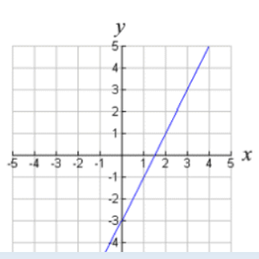
- y = -0.5x – 3
- y = -2x – 3
- y = 0.5x – 3
- y = 2x - 3

C

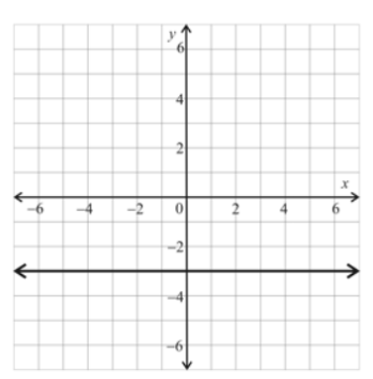
- What is the equation of the line shown?

- x = y – 3
- x= -3
- y = x – 3
- y = -3

D

- Solve: -2(x + 4) > 1 – 5x

- x > -3 D
- x < 3
- x < -3
- x > 3

- Find the x and y intercepts of the equation 3x + 4y = 12

- (4, 0) and (0, 3) A
- (0, 3) and (0, 4)
- (4, 0) and (3, 0)
- (3, 0) and (0, 4)

- Find the x and y intercepts of 25x² + 4y² = 9

- x intercepts are ($\frac{3}{5}, 0)$ and ($-\frac{3}{5}, 0)$, and y intercepts are (0, $\frac{3}{2}$ ) and (0, - $\frac{3}{2}$) A
- x intercepts are (5, 0) and (-5, 0) and y intercepts are (0, 3) and (0, -3)
- x intercepts are ($3, 0)$ and ($-\frac{3}{5}, 0)$, and y intercepts are (0, $3$ ) and (0, - $\frac{3}{2}$)
- x intercepts are ($\frac{3}{5}, 0)$ and ($-\frac{3}{5}, 0)$, and there are no y-intercepts

